Fusion data fabric is entirely event driven , Basically an execution happens when an event happens. Cleanse starts only when a particular event starts

When ever a table is created physical location will be adlsgen2

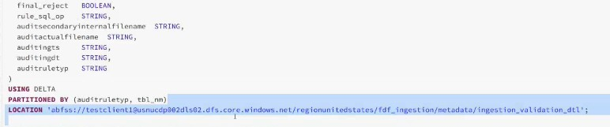

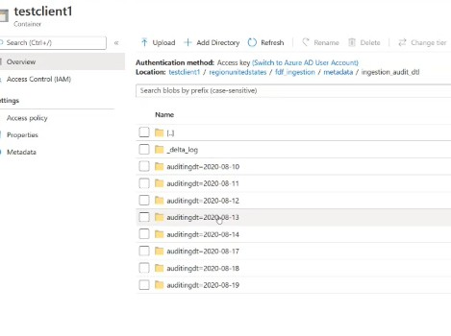

Basically I populate 3tables here . Actions here are

* Focus on the Ingestion order table and the location is writing

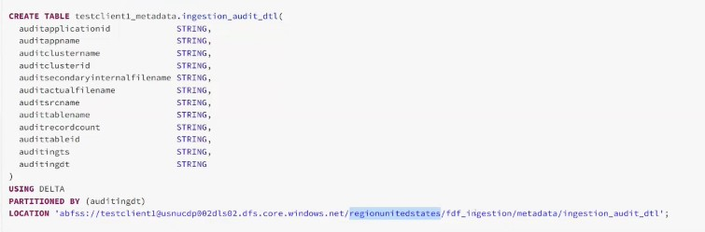

Whenever anytime when I am writing a blob or writing a file it is going to create an alert , so we are going to use for kickstarting the cleanse job

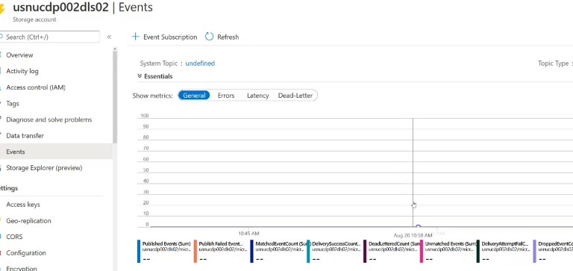

Preferrably event subscription has filters on it and here we are using Blob renamed and Directory renamed

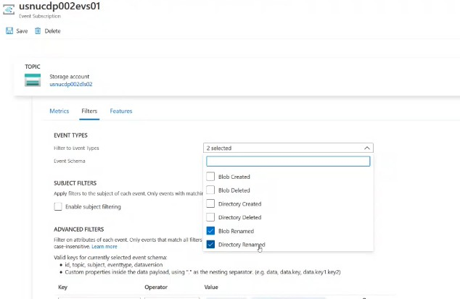

The advanced levelfilters are

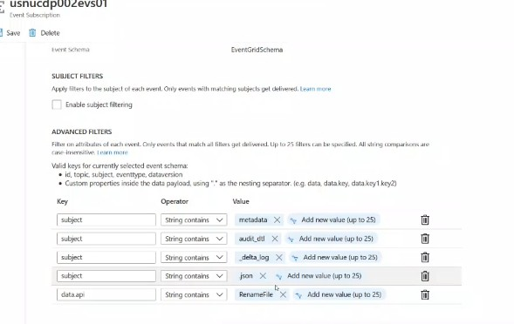

Writing the json file is the last step that sis going to happen in my job

Here we are saving the table as delta , and by default it is saving as parquet

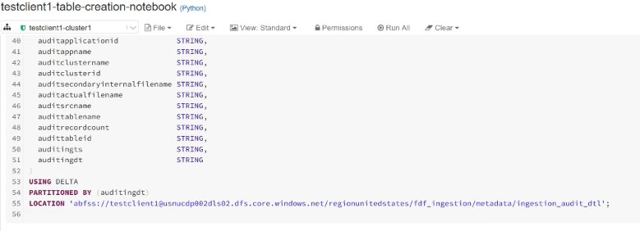

In delta lake it reads the history data and retrive it .Now look at the

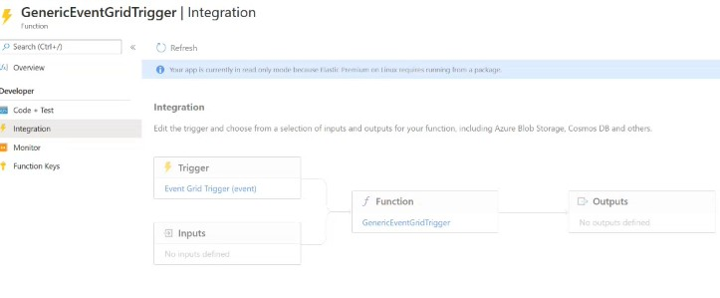

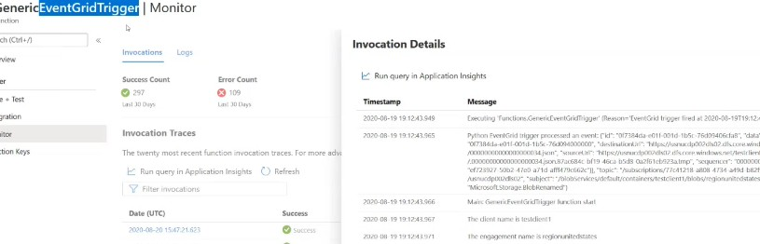

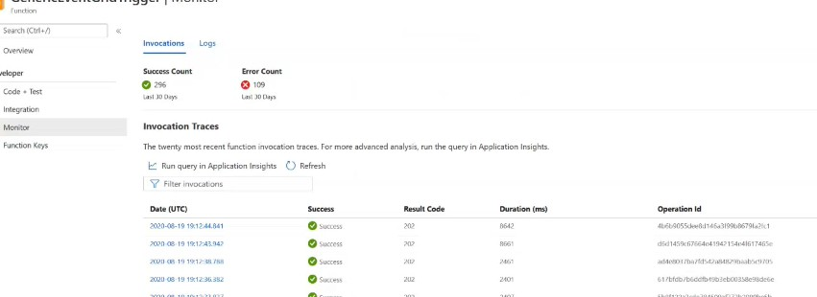

Azure Function is the subscriber of these events

Code for your event trigger

Here in the code the event that comes in is the json format like fieldids,topic,subject and eventtype.mostly subjecte is noted and the below is my sample event

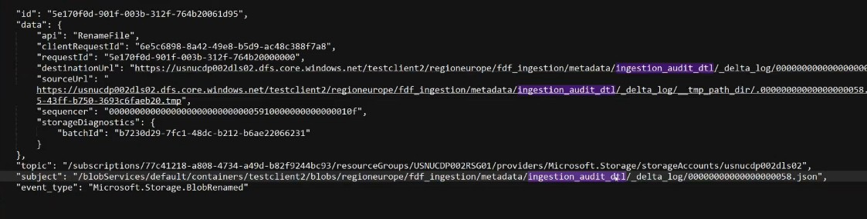

Here cleansing is nothing but running sql queries and cleaning your data

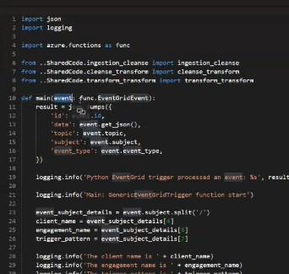

Here a function named as **ingestion_cleanse**

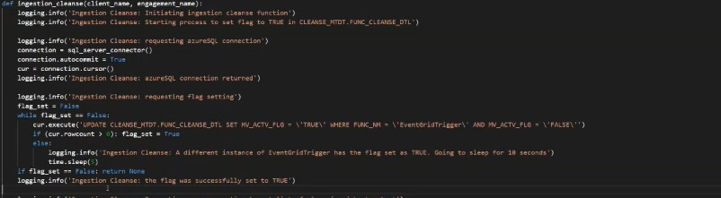

Now running the metadata. When the below query runs it’s a kind of comparing my injection metadata and cleanse metadata in terms of checkpoints

